iTrade System
FIX Gateway
Operation Manual
For SCB

CONFIDENTIAL INFORMATION: The contents of this document represent R&D work at Infocast and is hence not information that is in the public domain. Any disclosure, copying or distribution of this information other than to the intended recipients is strictly prohibited without the express written consent of Infocast Limited.
Document Information

File Name | 0000.doc
Document Description
Creation Date | 2/6/2006 10:32 AM
Last Updated | 2/6/2006 10:32 AM

Record of Updates

Date | Author | Version | Description
Feb 6, 2006 | Infocast Ltd. | 1.0 | Initial Version

Table of Content
1. Introduction 4
2. References 4
3. System Requirements 4
3.1 Hardware Requirements 4
3.2 Software Requirements 4
3.3 Communication Requirements 4
4. Installation 4
5. Operation 5
5.1 Start-up and shutdown 5
5.2 Start of Day 6
5.3 End of Day 6
6. Configuration 6
6.1 Update database setting 7
6.2 Add a FIX client (party) 7
6.3 Update schedule 9
6.4 Update Cameron FIX configuration file 9
6.5 Setup FIXgateway in HA mode 10

Introduction
This document describes the installation and operation procedure for FIX gateway.

References
- Financial Information Exchange Protocol (FIX) Specification, Version 4.2 (wit errata 20010501)
- CameronFIX XML Configuration Readme
- CameronFIX High Availability Readme

System Requirements

Hardware Requirements
- An application server with single Pentium 4 CPU or above is recommended.
- 1GB main memory or above

Software Requirements
- Microsoft Windows 2000 Server Edition
- Visibroker 6.5 runtime (redistributed with the release)
- Oracle database (version 9i)
- Oracle client (version 9i)
- JAVA 1.4.2_12 JDK or later
- iTrade System (including iChannel and NUT Server)
It is noted that the system may use other license free software components that are not listed here.

Communication Requirements
- A TCP connection between the FIX gateway and each FIX counterparties.
- SQL*Net connections between the FIX gateway and the Oracle database.
- CORBA connections (IIOP/TCP) between the FIX gateway and the iTrade system

Installation
The release consists of two archived file namely, <client>-fixgateway-<version>-<date>.tar.gz.

Directory/File | Description
conf/ | Contains all the configuration files
conf/project.properties | The configuration file contains the client specific placeholder properties
conf/project.override.properties | The configuration file contains the client specific overrides of default properties
conf/corba.properties | CORBA configuration file
conf/log4j.properties | Log4j logging configuration file
conf/eod.log4j.properties | Log4j logging configuration file for end of day process
conf/hibernate.properties | Hibernate configuration file
conf/ehcache.xml | Ehcache configuration file
dtd/ | DTD files
doc/ | Contains user manual and other documentation
sql/ | Contains the SQL scripts to create database user and tables
lib/ | Contains the runtimes libraries
log/ | Contains application log files
persistence/ | Contains the application data, such as sequence number, FIX messages
fixgateway.bat | The batch to launch FIX gateway on Windows platform
fixgateway.sh | The batch to launch FIX gateway on Unix platform
eod.bat | The batch to launch end of day command on Windows platform
eod.sh | The batch to launch end of day command on Unix platform
_eod.bat | The batch to cleanup local files as part of the end of day on Windows platform
_eod.sh | The batch to cleanup local files as part of the end of day on Unix platform

- Logon the application server with a dedicated user for running FIX gateway.
- Extract the <client>-fixgateway-<version>-<date>.tar.gz to the installation directory.
- Update the JAVA_HOME environment variable.
- Logon the database with a system user.
- Run the sql/<client>-fixgateway-user.sql to create a new database user (named FIXGATEWAY) dedicated for the FIX gateway.
- Change the database user password if necessary.
- Logon the database as ITRADESYS.
- Run the sql/<client>-fixgateway-itrade.sql
- Logon the database as FIXGATEWAY.
- Run the sql//<client>-fixgateway-investradeonym.sql to create the investradeonyms.
- Run the sql//<client>-fixgateway-tables.sql to create the tables
- Run the sql//<client>-fixgateway-data.sql to populate the tables with default data.
- Run the sql//<client>-fixgateway-package.sql to create stored procedures.
- Configure the FIX gateway (see section 6)
- Set the property “vbroker.agent.port” in the conf/corba.properties to the osagent port in use.

Operation

Start-up and shutdown
In Unix environment, execute fixgateway.sh start to start the FIX gateway as a background process and execute fixgateway.sh stop to stop the FIX gateway process. Moreover, one can check the process status by executing fixgateway.sh status.
The command line parameter is as follows.
fixgateway.sh start <application id>
eg. fixgateway.sh start default

In Windows environment, execute fixgateway.bat to start the FIX gateway and press Control-C key to top the process.

The application id is matched with the FIX_PARTY.APPLICATION_ID in the database table. This instance of FIX gateway only serves the FIX session defined in FIX_PARTY with matching application id.

Start of Day
There is no start of day process.

End of Day
The end of day process must be executed for each FIX clients daily. It can be executed as a scheduled task on system level or as a batch command manually. The execution time of the end of day process for each FIX client must be outside its online period. Running end of day during trading hours can be disastrous.
The end of day process does the following actions:
- Clear out all the persisted FIX messages in the database.
- Reset the FIX sequence numbers
- Delete all the FIX (or OMS) orders and trades maintained by the FIX gateway. However, the orders in the iTrade system are NOT deleted.
Both FIX parties should agree on the execution time of end of day such that the FIX sequence numbers are in pnsch the next time the FIX connection is established. Since the end of day process reset the FIX sequence number, the FIX sequence numbers, both incoming and outgoing, must start from one.

The end of day process consists of two parts, database cleanup and file cleanup. The file cleanup is defined in _eod.bat or _eod.sh that are customized for different clients. The batch files accept two parameters, namely external party company ID and our party company ID.

The operator may want to execute the end of day for a FIX party manually. The end of day process can be executed by running the eod.bat/eod.sh batch file.

eod <options> <external party> <our party>
where the options are
-force Force the execution of end of day.

Configuration
An example is used to illustrate the configuration of the FIX gateway. Suppose a buy side FIX gateway is configured with the following details.
- Company ID of the sell side party is UBS,
- Company ID of the buy side party is SCB,
- The buy side initiates the network connection to sell side.
- The sell side listens on port 4000 for the incoming connection from the buy side
- All FIX sequence numbers should start from one after the end of day.
- The default omnibus account is “0000001-0021”
- Symbol is in exchange specific format.
- The default exchange is SEHK. It is used when the FIX tag 100 (Exchange Destination) is omitted.
- If the FIX tag 100 (Exchange Destination) is specified, it is the “REUTERS” exchange code.

Update database setting

For Oracle’s JDBC thin driver, the connection URL has the format of jdbc:oracle:thin:@<database host name>:<database port number>:<database instance> for thin driver or jdbc:oracle:oci9:@<database instance> for OCI driver.
Database password
Database username
JDBC connection string
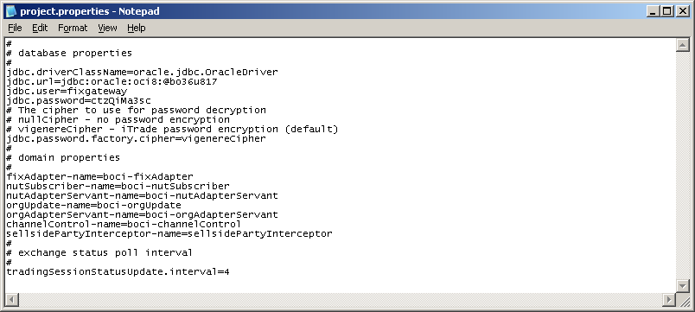

Add a FIX client (party)

To define a FIX session, the database table FIX_PARTY have to be configured.

Column | Description
EXTERNALPARTY | External FIX party company ID
OURPARTY | Our FIX party company ID
SELLSIDE | 1 if our party is of sell side or 0 if our party is of buy side
CORRELATOR | A correlator ID with the OMS. For iTrade, it is the iChannel ID for sell side or AMS ID for buy side.
ACCOUNT | For sell side FIX gateway, it is the default iTrade account for order placement by the counterparty if no account (FIX tag 1) is specified in the FIX new order message.  For buy side FIX gateway, it is the account (FIX tag 1) to send if the order does not have an omnibus account.
EXCHANGEID | The default iTrade exchange for order placement by the counterparty if no destination exchange (FIX tag 100) is specified in the FIX new order message.
EXCHANGECODE | The exchange code scheme of the destination exchange (FIX tag 100). It can be “REUTERS” or “MIC” The default is “REUTERS”
LAST_EOD_TIME | The time at which the last successful end of day process was executed for the counterparty.
LAST_LOGON_TIME | The last logon time
RESET_SEQ_NUM | The first logon message, sent by the FIX gateway, carries the FIX reset sequence number flag for the first logon message sent. This resets the sequence number on both sides after the FIX logon. It applies only to the parties that initiate the logon/connection and uses CameronFIX core library.
APPLICATION_ID | Each FIX gateway handle the FIX parties defined in this table with matching application ID. In other word, the application ID defines the particular FIX gateway that should handle this FIX party. For example, FIX gateway starts with application ID of “default” handles only FIX parties with application ID of “default”
ONLINE_START_TIME | The online start time of the FIX party.
ONLINE_END_TIME | The online end time of the FIX party. The FIX gateway stops accepting incoming connection to the party or stops making outgoing connection to the counterparty.
DONE_FOR_DAY | 1 if the party requires done for day message after market close or 0 if otherwise
FIX_VERSION | The FIX version string. For example, 4.0, 4.2
IDSOURCE | The exchange symbol scheme (FIX IDSOURCE Tag 22) It can be “ISIN”, “RICCODE” or “CUSIP”. This field is nullable.

Therefore, we should insert a record to FIX_PARTY as follows.

Column | Value
EXTERNALPARTY | UBS
OURPARTY | SCB
SELLSIDE | 0
CORRELATOR | UBS
ACCOUNT | 0000001-0021
EXCHNAGEID | SEHK
EXCHANGECODE | REUTERS
LAST_EOD_TIME | (NULL)
LAST_LOGON_TIME | (NULL)
RESET_SEQ_NUM | 0
APPLICATION_ID | default
ONLINE_START_TIME | 08:00:00
ONLINE_END_TIME | 18:00:00
DONE_FOR_DAY | 0
FIX_VERSION | 4.2
ID_SOURCE | (NULL)

Since we use Cameron FIX engine, we have to define FIX session details in the Cameron FIX configuration file named conf/cameronfix.xml. It is recommended to dedicate different listening ports for different FIX clients. For details of the Cameron FIX engine configuration file, please consult CameronFIX XML configuration document [2, 3].

Update schedule
A number of scheduled jobs are defined by FIX gateway. They requires no configuration if the default behaviour is fine.

Scheduled task | Description
Connection | For party that initiates connections to counterparty, online times (as defined in FIX_PARTY.ONLINE_START_TIME and FIX_PARTY.ONLINE_END_TIME) represent the range of time that the party attempts to make a network connection to the counterparty continuously.  For party that accepts connections from counterparties, online times (as defined in FIX_PARTY.ONLINE_START_TIME and FIX_PARTY.ONLINE_END_TIME) represent the range of time that the party will accept network connection. FIX logon outside the online time will be rejected.
Done For Day | Unexecuted or partially executed orders are subjected to order status transition to “done for day” after the market close. It indicates to the FIX counter party that there are no further executions for the orders on the trading day. The “done for day” messages are sent at 16:15 and 16:45 for SEHK by default.  The schedule can be overridden by overriding the property “sehkDoneForDayTrigger.cronExpression” in conf/project.override.properties

Update Cameron FIX configuration file
The Cameron FIX engine is configured in conf/cameronfix.xml as follows.
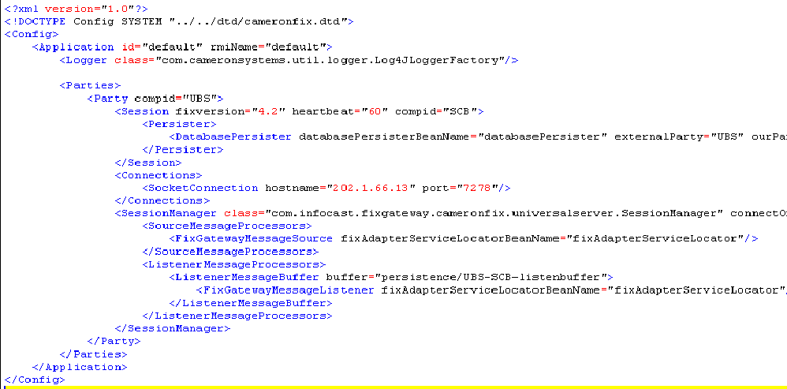
Counterparty
Our party
FIX heartbeat interval
Connection IP & port

Setup FIXgateway in HA mode

Edit conf\default\application.properties

Sample :
#
# Cluster config
#
clusterEnabled=true
groupName=FIXHAGroup
networkDetectorCommand=ping -n 1 192.168.1.249
appID=1
bindAddress=192.168.1.145
multicast-ip=228.0.0.1
multicast-port=4000

To enable / disable fixgateway in HA mode, set clusterEnabled true / false
appID must be unique for each machine

bindAddress is the IP address of the FIXgateway machine
Set bindAddress with IP adress of the server machine if only one network card available.
In case more than one network card exist, set bindAddress with the IP address of one of network card and set the multicast-ip accordingly. bindAddress cannot be “localhost” or “127.0.0.1”

Remark: Only one FIXgateway should be in active mode, all other should be in standby mode when multiple FIXgateway are running.

